LAB PRACTICE ASSIGNMENT: 2

Create a table EMPLOYEE with following schema:
(Emp_no, E_name, E_address, E_ph_no, Dept_no, Dept_name,Job_id , Salary)

Write SQL queries for following question:
- Insert aleast 5 rows in the table.
- Display all the information of EMP table.
- Display the record of each employee who works in department D10.
- Update the city of Emp_no-12 with current city as Nagpur.
- Display the details of Employee who works in department MECH.
- Delete the email_id of employee James.
- Display the complete record of employees working in SALES Department.

Step 1: Use Database

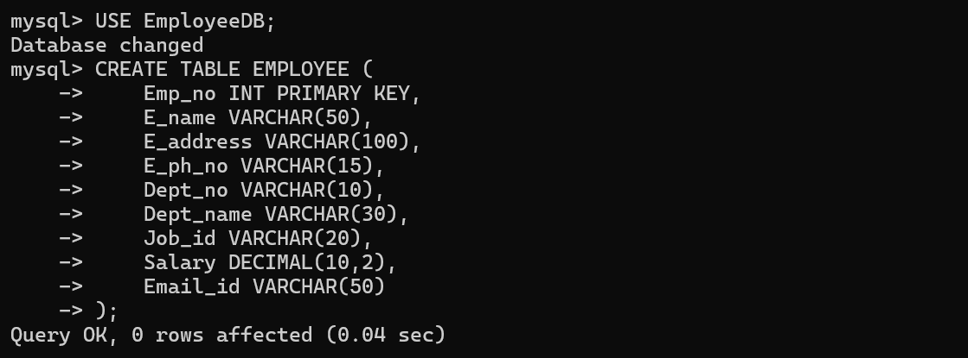

Step 2: Create EMPLOYEE Table

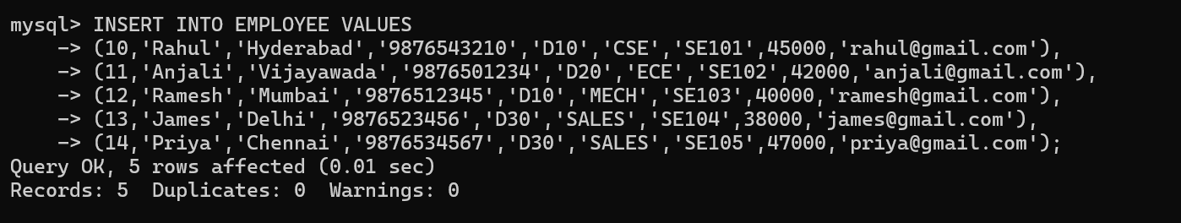
Step 3: Insert At Least 5 Records
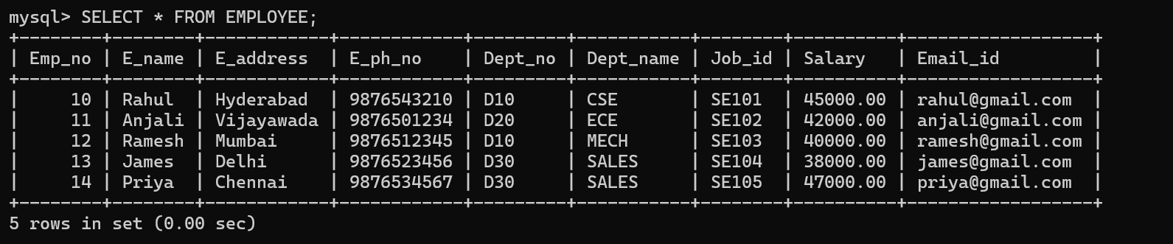

Step 3: Insert At Least 5 Records
- Display All Information
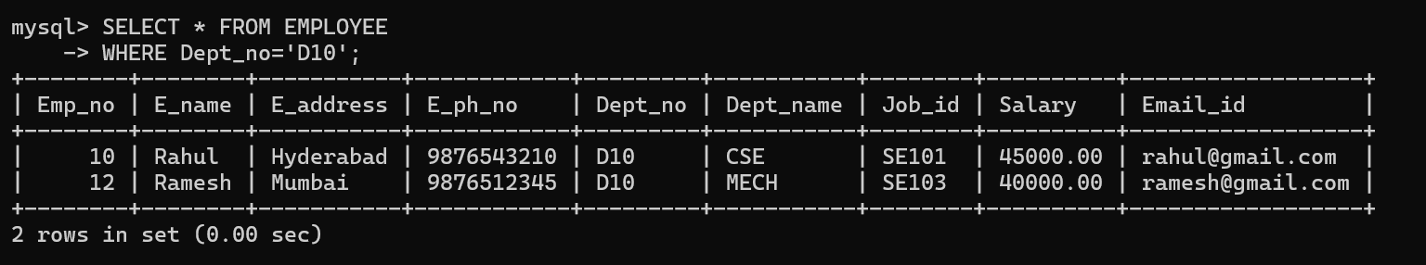
- Display Employees Working in Department D10
- Update City of Employee No. 12 to Nagpur
- Display Employees Working in MECH Department
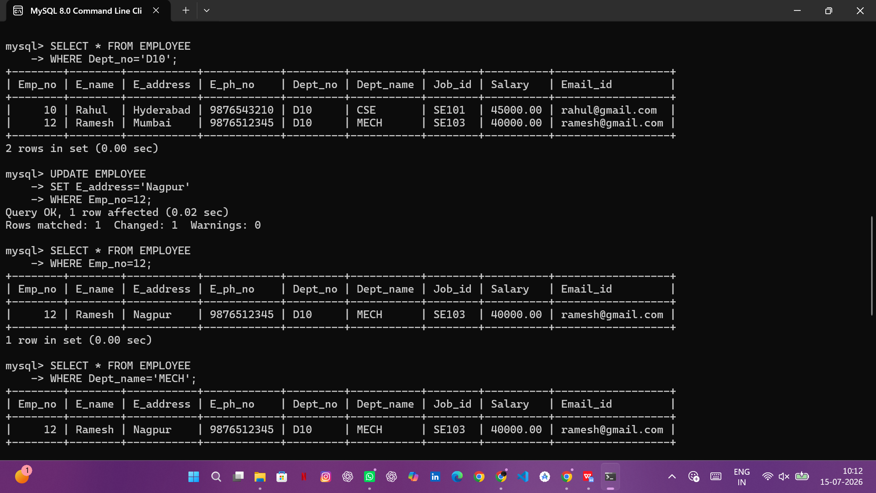
- Delete Email ID of Employee James

- Display Employees Working in SALES Department
